Statistics Digital Assignment 1

Name: Om Ashish Mishra

Registration Number: 16BCE0789

Slot: E1

Course code: MAT2001

Course name: Statistics for Engineers

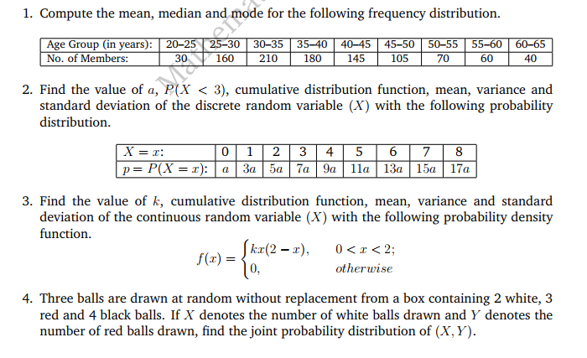

Ans:

|  |  |  |  |  |  |  |
| --- | --- | --- | --- | --- | --- | --- |
| Age Group(in years) | Mid class value (xi) | xi-A | Di=(xi-A)/5 | No. of Members (fi) | Cumulative frequency | Di * fi |
| 20-25 | 22.5 | -15 | -3 | 30 | 30 | -90 |
| 25-30 | 27.5 | -10 | -2 | 160 | 190 | -320 |
| 30-35 | 32.5 | -5 | -1 | 210 | 400 | -210 |
| 35-40 | 37.5 = A | 0 | 0 | 180 | 580 | 0 |
| 40-45 | 42.5 | 5 | 1 | 145 | 725 | 145 |
| 45-50 | 47.5 | 10 | 2 | 105 | 830 | 210 |
| 50-55 | 52.5 | 15 | 3 | 70 | 900 | 140 |
| 55-60 | 57.5 | 20 | 4 | 60 | 960 | 240 |
| 60-65 | 62.5 | 25 | 5 | 40 | 1000 | 200 |
| TOTAL: | | | | 1000 |  | 315 |

Mean = ( Σ xifi ) / n = (315*5)/1000 + 37.5 = 39.075

Median = l + x C = 35 + x 5 = 37.778

Here observation is 500th thus it lies in the range 35-40 age group taken.

Mode = l + x C = 30 + x 5 = 33.135

Here the max frequency is 210 therefore 30-35 age group is considered.

Answer: Mean=39.075, Median=37.778, Mode=33.135



Ans:

Value of a:

a + 3a + 5a + 7a + 9a + 11a + 13a + 15a + 17a = 1 => a = 1/81

P(X<3):

P(X<3) = P(X=0)+P(X=1)+P(X=2) = a+3a+5a = 9a = 1/9

Cumulative distribution function:

F(x) = (x^2 + x)/81

Mean:

E(x) = 5.481

Variance:

V(x) = E2(x) – (E(x))2 = 4.471

Standard Deviation:

S.D(x) = = = 2.116



Ans:

The Value of k:

= 1 => k = 3/8

Cumulative distribution function:

F(x) =

Mean:

Mean =

Variance:

Varience =

Standard deviation:

Standard deviation =



Ans:

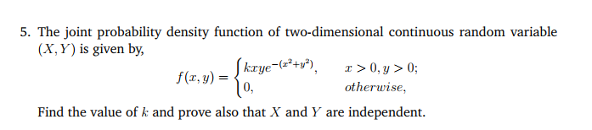

Ans: